Name:

Haunted Code Chronicles: Mission 5

Warm-Up
This mission uses division. What are the parts of a long division problem? | 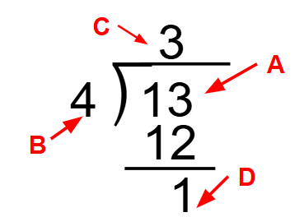
Answer these division problems:  - $19 ÷ 5$  - $8 ÷ 3$  - $4 ÷$6  - $24 ÷ 4$
   | Quotient | Remainder
  A
  B
  C
  D
Mission 5 – The Library
Mission 5 Objective 1: Read the instructions and the Hints.
What is your plan for knocking off the box?
After completing the challenge, read the completion message. Click on the tool 🔧Modulo. What Python code gives the quotient and remainder separately?
Mission 5 Objective 2: Read the instructions.
Light up each lamp individually, following the instructions. Is there a pattern?
Light up all the lamps at the same time. What happens?
Follow CodeTrek. Run the code again. Change the camera to Rotate to see the Spectral Energy Card. What do you observe?
Mission 5 Objective 3: Read the instructions in the Objective Panel and in CodeTrek.
What code cycles to the next light?
Why do you need this line of code:
if light == 5:
light = 0
Mission 5 Objective 4: Read the instructions and Hints
What is “Epoch time”?
What code lets you achieve “floor”?
What is “mod” short for? What symbol in Python do you use for it?
Modify your code in the Lamplighter program to complete the challenge. Use the Hints for the equation. Then run the code and watch the spectral energy reach 100.
Mission 5 Objective 5: Read the instructions and the Hints.
Follow CodeTrek and the Hints to drive CodeBot up the fallen shelf. It will fall off.
Mission 5 Objective 6: Read the instructions and Hints.
What is the accelerometer?
When CodeBot’s nose is pointed straight up, what is the x-axis?
Which way do you steer if the x-axis is negative?
Which way do you steer if the x-axis is positive?
Use CodeTrek to help with the code. The second Hint also provides some really useful information.
Reflection
Other than the spectral dance, what is another example of when to use modulo?
Other than driving uphill, what is another example of when to use the accelerometer?

